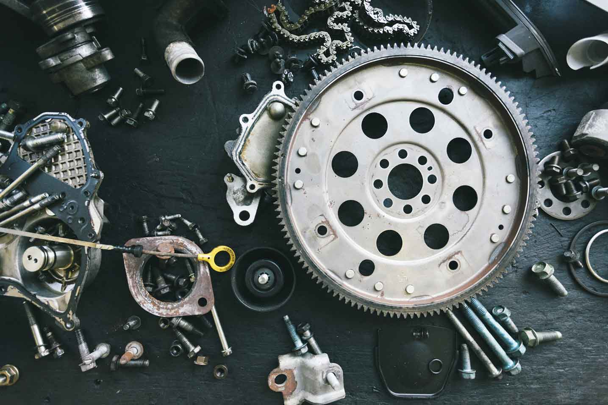­­­­­

|  |  |
| --- | --- |
|  |  |



Process Definition

Document

Smart Printing Solution

Table of Contents

I. INTRODUCTION 4

1.1 Purpose 4

1.2 Objectives 4

1.3 Key Contacts 5

1.4 Minimum Pre-requisites for the Automation 5

II. AS IS Process description 5

2.1 Applications Used 7

2.2 AS IS Process Map 7

2.2.1 High Level Process Map 8

2.2.2 Detailed Level Process Map 8

III. TO BE Process description 11

3.6. Applications Errors & Exceptions Handling 13

3.6.1. Known Applications Errors and Exceptions 13

# INTRODUCTION



## Purpose

Printing multiple files manually can be a time-consuming and error-prone task, especially when dealing with large volumes of documents. However, our Smart Printing System aims to streamline this process by automating the entire printing operation. With its intuitive graphical user interface (GUI), users can effortlessly specify the folder path containing the PDF files to be printed and define the desired output path for the generated documents. Gone are the days of manually opening each file and initiating the print command individually.

**PDD is a communication document between:**

* The RPA Business Analyst and the SME/Process Owner. The goal is to ensure that the RPA Business Analyst has the correct understanding of the process and has represented it accurately.
* The RPA Business Analyst and the Development team (represented by the Solution Architect and RPA Development Lead). The goal is to ensure that the process is documented appropriately and to a sufficient level of detail so that the Solution Architect can then create the solution based on the PDD content.

## Objectives

The business objectives and benefits expected by the tool Owner after automation of the selected printing process are:

* To Automate whole printing process
* To reduce Manual Intervention and improve efficiency of workers

## Key Contacts

Add here any stakeholders that need to be informed or to approve changes to the process:

|  |  |  |  |
| --- | --- | --- | --- |
| Role | Name | Contact Details (email, phone number) | Notes |
| Developer | Shivasing Borade | 9730955676 |  |
|  | 0 |  |  |

## Minimum Pre-requisites for the Automation

1. Windows operating System
2. Latest [python](https://www.python.org/downloads/) version should be installed on PC
3. Python modules tkinter, pyautogui, keyboard should be installed.
4. Shortcut named auto should be present in windows folder in c drive
5. Popup’s and error messages should be turned off strictly in Auto scan software.

# AS IS Process description

In this section the Business Analyst will document the process. This section will serve as the starting point for the re-engineering and automation effort.



## Applications Used

The table includes a comprehensive list of all the applications that are used as part of the process to be automated to perform the given actions in the flow.

|  |  |  |  |  |  |
| --- | --- | --- | --- | --- | --- |
| Application Name | Version | Application Language | Thin/Thick Client | Environment/ Access method | Comments |
| Python | 3.11.3 | *Python* |  |  |  |

## AS IS Process Map

This section contains various process maps contributing to a better understanding of how the process is performed pre-automation.

### High Level Process Map

This section is useful for the Business Analyst in presentations and discussions with management to underline areas of weakness, inefficiency or to demonstrate which actions could be in scope

.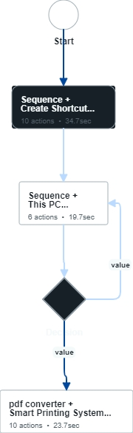

### Detailed Level Process Map

This section describes the process at key-stroke level and is an essential part for the communication with the developers.

## Process Statistics

**High Level statistics**

|  |  |  |  |  |  |  |  |
| --- | --- | --- | --- | --- | --- | --- | --- |
| Processes | Windows | Actions | Mouse clicks | Keys pressed | Text entries | Hotkeys used | Time |
| 2 | 8 | 22 | 20 | 4 | 2 | 1 | 1 min. 30 sec. |
|  |  |  |  |  |  |  |  |
|  |  |  |  |  |  |  |  |

**Detailed statistics**

|  |  |  |  |
| --- | --- | --- | --- |
| Window name | Mouse clicks | Text entries | Key pressed |
|  | 6 | 0 | 0 |
| Create Shortcut | 3 | 1 | 4 |
| Browse for Files or Folders | 4 | 0 | 0 |
| This PC | 1 | 0 | 0 |
| Local Disk (C:) | 1 | 0 | 0 |
| Destination Folder Access Denied | 1 | 0 | 0 |
| pdf converter | 1 | 0 | 0 |
| Smart Printing System | 3 | 2 | 0 |
|  |  |  |  |
|  |  |  |  |

## Detailed As Is Process Actions

|  |  |  |  |  |  |
| --- | --- | --- | --- | --- | --- |
| #Action | Input | Description | Details (Screen/Video Recording Index) | Exceptions Handling | Possible Actions |
|  |  |  |  |  |  |
|  |  |  |  |  |  |

|  |  |
| --- | --- |
| 1. Creating Shortcut | |
|  | **Est. time: 16.0 sec.** |

|  |  |
| --- | --- |
| * 1. Left click using mouse |  |
|  | Est. time: 6.7 sec. |
| image | Action: Click |

|  |  |
| --- | --- |
| * 1. Go to New |  |
|  | Est. time: 3.9 sec. |
| image | Action: Click |

|  |  |
| --- | --- |
| * 1. Click ok on shortcut |  |
|  | Est. time: 5.4 sec. |
| image | Action: Click |

|  |  |
| --- | --- |
| 1. Create Shortcut | |
|  | **Est. time: 3.2 sec.** |

|  |  |
| --- | --- |
| * 1. Browse the path of autoscan.exe file |  |
|  | Est. time: 3.2 sec. |
| image | Action: Click |

|  |  |
| --- | --- |
| 1. Browse for Files or Folders | |
|  | **Est. time: 17.7 sec.** |

|  |  |
| --- | --- |
| * 1. Navigate to automate.exe file |  |
|  | Est. time: 8.4 sec. |
| image | Action: Click |

|  |  |
| --- | --- |
|  |  |
|  | Est. time: 3.8 sec. |
| image | Action: Click |

|  |  |
| --- | --- |
|  |  |
|  | Est. time: 3.2 sec. |
| image | Action: Click |

|  |  |
| --- | --- |
|  |  |
|  | Est. time: 2.3 sec. |
| image | Action: Click |

|  |  |
| --- | --- |
| 1. Create Shortcut Name auto | |
|  | **Est. time: 15.1 sec.** |

|  |  |
| --- | --- |
| * 1. Click next |  |
|  | Est. time: 3.3 sec. |
| image | Action: Click |

|  |  |
| --- | --- |
| * 1. Give the shortcut name auto |  |
| If you give another name to your shortcut code will not work. Creating shortcut is one time process you don't need to do this step again and again. | Est. time: 8.2 sec. |
| image | Action: Keyboard Input |

|  |  |
| --- | --- |
|  |  |
|  | Est. time: 3.6 sec. |
| image | Action: Click |

|  |  |
| --- | --- |
| 1. Move file to Windows folder in C drive | |
|  | **Est. time: 9.4 sec.** |

|  |  |
| --- | --- |
| * 1. Copy/cut file |  |
|  | Est. time: 4.1 sec. |
| image | Action: Click |

|  |  |
| --- | --- |
|  |  |
|  | Est. time: 5.3 sec. |
| image | Action: Click |

|  |  |
| --- | --- |
| 1. This PC | |
|  | **Est. time: 3.0 sec.** |

|  |  |
| --- | --- |
| * 1. Navigate to C drive |  |
|  | Est. time: 2.10 sec. |
| image | Action: Double Click |

|  |  |
| --- | --- |
| 1. Local Disk (C:) | |
|  | **Est. time: 1.4 sec.** |

|  |  |
| --- | --- |
| * 1. Go to Windows Folder |  |
|  | Est. time: 1.4 sec. |
| image | Action: Double Click |

|  |  |
| --- | --- |
| 1. Sequence | |
|  | **Est. time: 3.5 sec.** |

|  |  |
| --- | --- |
| * 1. Paste the file In Windows folder |  |
|  | Est. time: 3.5 sec. |
| image | Action: Click |

|  |  |
| --- | --- |
| 1. Destination Folder Access Denied | |
|  | **Est. time: 2.4 sec.** |

|  |  |
| --- | --- |
| * 1. Click Continue |  |
|  | Est. time: 2.4 sec. |
| image | Action: Click |

|  |  |
| --- | --- |
| 1. Decision | |
| Check If proper shortcut is present in Window folder | **Est. time: 0.0 sec.** |

|  |  |
| --- | --- |
| 1. pdf converter | |
|  | **Est. time: 5.4 sec.** |

|  |  |
| --- | --- |
| * 1. Navigate to folder where int1.py is stored |  |
|  | Est. time: 5.4 sec. |
| image | Action: Double Click |

|  |  |
| --- | --- |
| 1. Smart Printing System | |
|  | **Est. time: 13.0 sec.** |

|  |  |
| --- | --- |
| * 1. Add Path of Folder |  |
| Add path of the folder in which all files to be converted into pdf are stored. | Est. time: 2.3 sec. |
| image | Action: Click |

|  |  |
| --- | --- |
| * 1. Add path of folder |  |
| Here give the path of folder in which you want to store the pdf files. | Est. time: 1.9 sec. |
| image | Action: Click |

|  |  |
| --- | --- |
| * 1. Click Print Pdfs |  |
| From here printing will start | Est. time: 8.8 sec. |
| image | Action: Click |

|  |  |
| --- | --- |
|  |  |
|  | Est. time: 0.0 sec. |
| image | Action: Hotkey |

|  |  |
| --- | --- |
| 1. Event | |
|  | **Est. time: 0.0 sec.** |

# TO BE Process description

## Applications Errors & Exceptions Handling

A comprehensive list of all errors, warnings or notifications should be consolidated here together with the action to be taken for each by the worker.

### Known Applications Errors and Exceptions

Details regarding how the worker should handle the exceptions.

|  |  |  |  |
| --- | --- | --- | --- |
| Error/Exception Name | Action | Parameters | Action to be taken |
| *Pop up windows or*  *Error message appear*  *While printing* | ***Close the application and re-run (process will start from first)*** | ***_*** | ***Close the program running immediately otherwise wrong document will print*** |
|  |  |  |  |

